Anthony Cunningham

STAT: 2010

10/26/2016

**Homework 9 SAS Code**

#46. **data** tcells;

input baseline twentyDaysLater;

diff = twentyDaysLater - baseline;

datalines;

0.04 0.28

0.02 0.47

0.00 1.30

0.02 0.25

0.38 1.22

0.33 0.44

;

**run**;

**proc** **univariate** plot data=tcells; *to check outliers, normality, and to find t and p values;

var diff;

**run**;

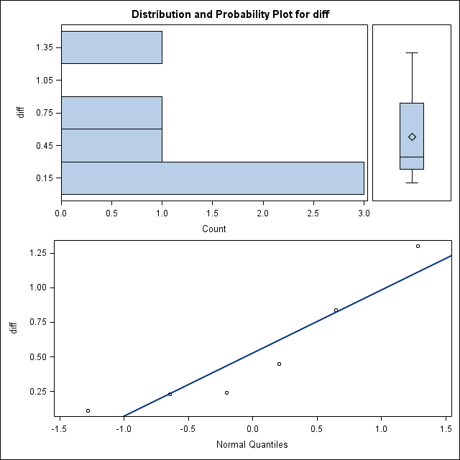

Tests for Location: Mu0=0

Test -Statistic- -----p Value------

Student's t t 2.829613 Pr > |t| 0.0367

Sign M 3 Pr >= |M| 0.0313

Signed Rank S 10.5 Pr >= |S| 0.0313

#47. **proc** **means** data=tcells n mean stddev clm; *find population mean;

var diff;

**run**;

The MEANS Procedure

Analysis Variable : diff

Lower 95% Upper 95%

N Mean Std Dev CL for Mean CL for Mean

6 0.5283333 0.4573584 0.0483652 1.0083015

Ch 19: #49.

**data** sublim ;

input group $ before after ;

change = after - before ;

datalines;

T 18 24

T 18 25

.

.

C 19 31

;

**run** ;

**proc** **sort** data = sublim ;

by group ;

**run** ;

**proc** **univariate** plot data = sublim ; *to check for outliers, normality of both groups;

var change ;

by group ;

**run** ;

*control group *test group

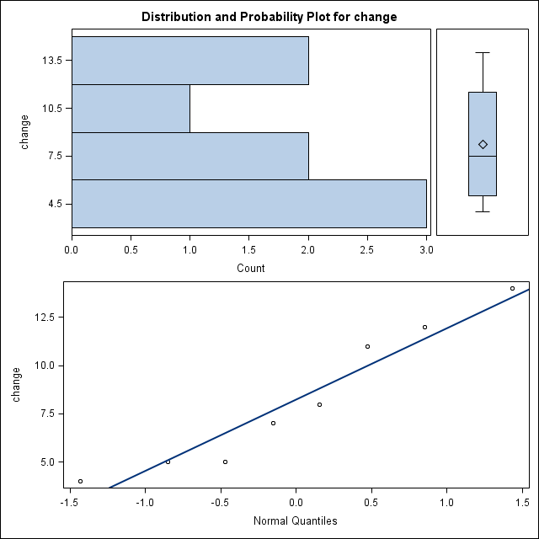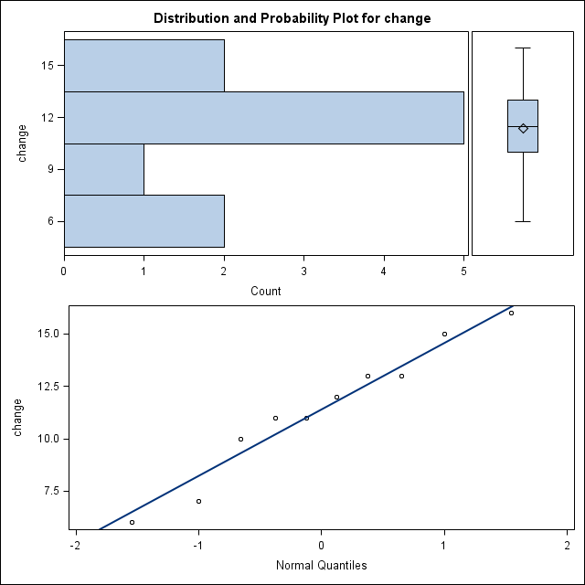

**proc** **ttest** alpha = **0.10** data = sublim ; *to find t and two-sided p- values, and confidence interval;

class group ;

var change;

**run** ;

*t and p-values

Method Variances DF t Value Pr > |t|

Pooled Equal 16 1.95 0.0691

Satterthwaite Unequal 13.919 1.91 0.0765

*confidence interval at 90%

group Method Mean 90% CL Mean Std Dev 90% CL Std Dev

C 8.2500 5.7759 10.7241 3.6936 2.6055 6.6380

T 11.4000 9.5628 13.2372 3.1693 2.3115 5.2141

Diff (1-2) Pooled 3.1500 0.3272 5.9728 3.4086 2.6588 4.8321

Diff (1-2) Satterthwaite 3.1500 0,2494 6.0506